Assignment
Fundamental Theory
(LAB: 7)
NAME: Majid Ali
CMS ID: 053-25-0017
PROGRAM: Software engineering (Section: A)

Question 1
Using nested loops, write separate C++ programs to generate each of the following outputs.
(i)
#include <iostream>
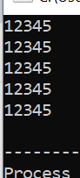
using namespace std;
int main(){
int n=5;
for(int i=1; i<=n; i++){
for(int j=1; j<=n; j++){
cout<<""<<j;
}
cout<<endl;
}
return 0;
}
(ii)
#include <iostream>
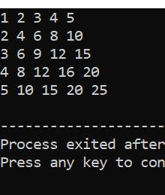
using namespace std;
int main(){
int n=5;
for(int i=1; i<=n; i++){
cout<<"";
for(int j=1; j<=n; j++){
cout<<j*i<<" ";
}cout<<endl;}
return 0;}
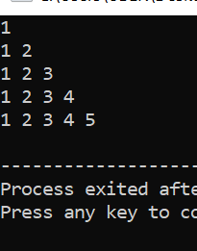
(iii)
#include <iostream>
using namespace std;
int main(){
int n=5;
for(int i=1; i<=n; i++){
for(int j=1; j<=i; j++){
cout<<j<<" ";
}
cout<<endl;
}
return 0;
}

(iv)
#include <iostream>
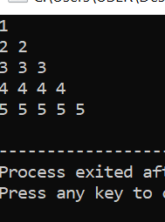
using namespace std;
int main(){
int n=5;
for(int i=1; i<=n; i++){
for(int j=1; j<=i; j++){
cout<<i<<" ";
}
cout<<endl;}
return 0;
}
(v)
#include <iostream>
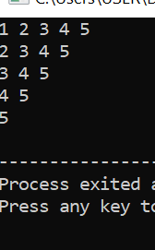
using namespace std;
int main(){
int n=5;
for(int i=1; i<=n; i++){
for(int j=i-0; j<=n; j++){
cout<<j<<" ";
}
cout<<endl;
}
return 0;
}

(vi)
#include <iostream>
using namespace std;
int main(){
int n=4;
for(int i=1; i<=n; i++){
for(int j=1; j<=n-i; j++){
cout<<" ";
}
for(int k=1; k<=i; k++){
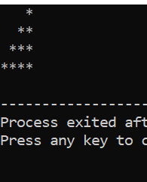
cout<<"*";
}
cout<<endl;
}
return 0;
}

(vii)
#include <iostream>
using namespace std;
int main(){
int n=4;
for(int i=1; i<=n; i++){
for(int j=1; j<=i; j++){
cout<<"*";
}
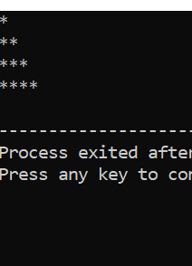
cout<<endl;
}
return 0;
}

(viii)
#include <iostream>
using namespace std;
int main(){
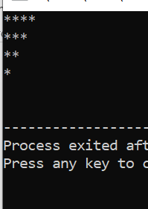
int n=4;
for(int i=1; i<=n; i++){
for(int j=i-1; j<=n-1; j++){
cout<<"*";
}
cout<<endl;
}
return 0;
}

(ix)
#include <iostream>
using namespace std;

int main() {
int n;
cout << "Enter number: ";
cin >> n;
for (int i = 1; i <= n; i++) {
// Print spaces
for (int j = i; j < n; j++) {
cout << " ";
}
// Print stars
for (int k = 1; k <= (2 * i - 1); k++) {
cout << "*";
}
cout << endl;
}

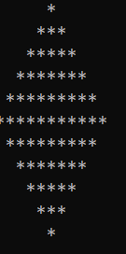
// Lower half of diamond
for (int i = n - 1; i >= 1; i--) {
// Print spaces
for (int j = n; j > i; j--) {
cout << " ";
}
// Print stars
for (int k = 1; k <= (2 * i - 1); k++) {
cout << "*";
}
cout << endl;
}
return 0;}
x
#include <iostream>
using namespace std;

int main() {
int i, j;
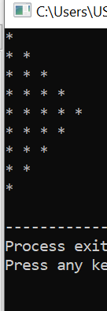
// Upper part
for (i = 1; i <= 5; i++) {
for (j = 1; j <= i; j++) {
cout << "* ";
}
cout << endl;
}

// Lower part
for (i = 4; i >= 1; i--) {
for (j = 1; j <= i; j++) {
cout << "* ";
}
cout << endl;
}
return 0;
}
Q 2:
Write a program that computes average test scores of students. The program should first ask the user to input total number of students and then the number of test scores per student. After that, for each student, ask the user to enter test scores and compute (and display) the average test score of every student, as shown in the sample output below:
#include <iostream>
using namespace std;
int main(){
int test_score,num_stu,score1,score2,score3;
float average;
cout<<"This program averages test score."<<endl;
cout<<"For how many students do you have scores? ";
cin>>num_stu;
cout<<"How many test scores does each student have? ";
cin>>test_score;
int i;
for( i=1; i<=num_stu; i++){
float average;
cout<<"Enter score 1 for student"<<i<<":";
cin>>score1;
cout<<"Enter score 2 for student"<<i<<":";;
cin>>score2;
cout<<"Enter score 3 for student"<<i<<":";;
cin>>score3;
average=(score1=score2+score3)/3.0;
cout<<"The average score for student "<<i<<"is: "<<average<<"."<<endl;
cout<<endl;
}
return 0;
}
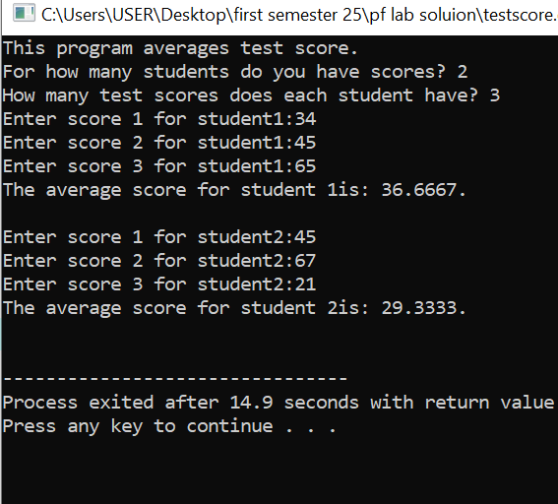

Q 3:
Write a program that asks the user to input an integer value that denotes the range up to which tables of number should be printed. Then, tables of all the numbers from 1 to that range value should be displayed, as shown below:
#include <iostream>

using namespace std;

int main(){
string cont;
int tableNumber;
do{

cout<<"Enter you want to table: ";
cin>>tableNumber;
for(int i = 1; i <=10; i++){
cout<<tableNumber<<" * "<<i<<" = "<<tableNumber*i<<endl;
}
cout<<"Do you enter again [yes or no ] ";
cin>>cont;
}while(cont == "yes");
return 0;
}

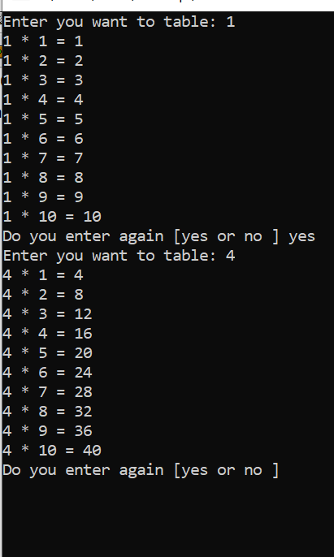

WHILE AND DO WHILE LOOP
1
Exercises of While and Do while Loop: 1. Write a C++ program that should continuously ask the user to input any integer number until and unless a negative number is entered. When a negative number is entered, then the program should end and print the sum of all the entered numbers. However, it should also check that large numbers (greater than 30) should not be considered for calculating the sum, like shown below:
#include <iostream>
using namespace std;
int main() {
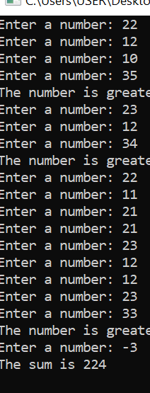
int num, sum = 0;
do {
cout << "Enter a number: ";
cin >> num;

if (num > 30) {
cout << "The number is greater than 30 and won't be calculated." << endl;
continue;
}
if (num >= 0)
sum += num;
} while (num >= 0); // stop when negative number entered
cout << "The sum is " << sum << endl;
return 0;
}

2
#include <iostream>
#include<iomanip>
using namespace std;

int main() {
int totalNumbers;
double num, lowest, highest;

cout << "How many numbers do you have? > ";
cin >> totalNumbers;

cout << "Please enter a number_1 --> ";
cin >> num;

lowest = highest = num;
for (int i = 2; i <= totalNumbers; i++) {
cout << "Please enter a number_" << i << " --> ";
cin >> num;

if (num < lowest)
lowest = num;

if (num > highest)
highest = num;
}

cout << "\nThe lowest number is "<<fixed<<setprecision(2) << lowest << endl;
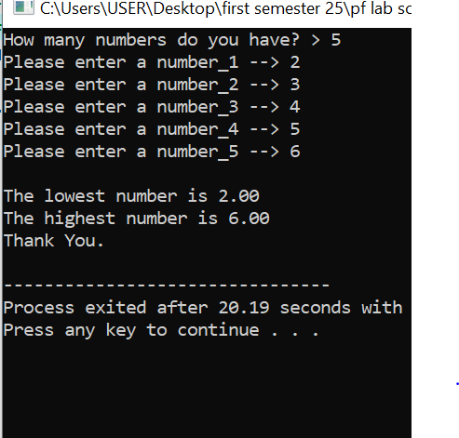
cout << "The highest number is " <<fixed<<setprecision(2) << highest << endl;
cout << "Thank You." << endl;

return 0;
}

3
Create a Guessing Game program, where you will guess a number. For now, assume any fixed number of choices as the actual number to be guessed (means, hardcode that value inside the code). Then, continuously ask the user to guess the number (I.e., input the number) unit and unless he/she guesses it correctly. Display the message(s) to the user as described below: • If the entered number is smaller than the actual number, then you should display a message saying the user that his/her entered number is smaller than the actual number • If the entered number is greater than the actual number, then you should display a message saying the user that his/her entered number is greater than the actual number • If the user guesses the number correctly (I.e., enters the actual number), then display a Congrats message, as shown below:
#include <iostream>
using namespace std;

int main() {
int actualNumber = 7; // 🎯 Hardcoded number to guess
int guess;

cout << "Welcome to the Guessing Game!" << endl;

do {
cout << "Guess the number: ";
cin >> guess;

if (guess < actualNumber)
cout << "Your guess is smaller than the actual number." << endl;
else if (guess > actualNumber)
cout << "Your guess is greater than the actual number." << endl;
else
cout << "🎉 Congratulations! You guessed the number correctly!" << endl;

} while (guess != actualNumber); // loop until correct guess

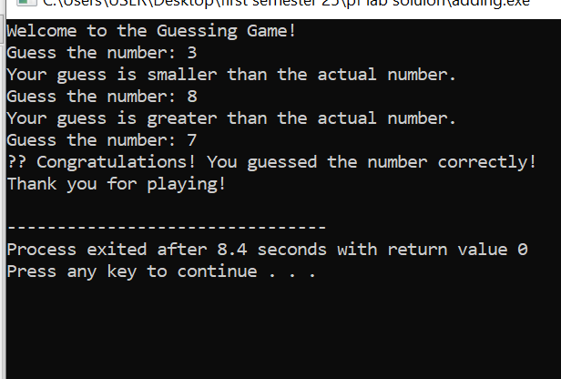
cout << "Thank you for playing!" << endl;
return 0;
}

4
Extend the Guessing Game program created above. Other rules are the same as stated in the previous part. However, in this program, the actual number’s value should be fixed between 1 and 100 and the user should be allowed only five (05) attempts. If the user guesses the number within five attempts, then display a Congrats message. Otherwise, the program should end after five wrong attempts, and display a sorry message to the user and the actual number as well.
#include <iostream>
using namespace std;

int main() {
int actualNumber = 45; // 🎯 Hardcoded number between 1 and 100
int guess;
int attempts = 0;
const int maxAttempts = 5;

cout << "Welcome to the Guessing Game!" << endl;
cout << "Guess a number between 1 and 100." << endl;

do {
cout << "\nAttempt " << (attempts + 1) << " of " << maxAttempts << endl;
cout << "Enter your guess: ";
cin >> guess;

attempts++;

if (guess < actualNumber)
cout << "Your guess is smaller than the actual number." << endl;
else if (guess > actualNumber)
cout << "Your guess is greater than the actual number." << endl;
else {
cout << "🎉 Congratulations! You guessed the number correctly in "
<< attempts << " attempt(s)!" << endl;
break; // stop if correct
}

} while (attempts < maxAttempts);

if (guess != actualNumber) {
cout << "\nSorry! You've used all " << maxAttempts << " attempts." << endl;
cout << "The actual number was: " << actualNumber << endl;
}cout << "Thank you for playing!" << endl;
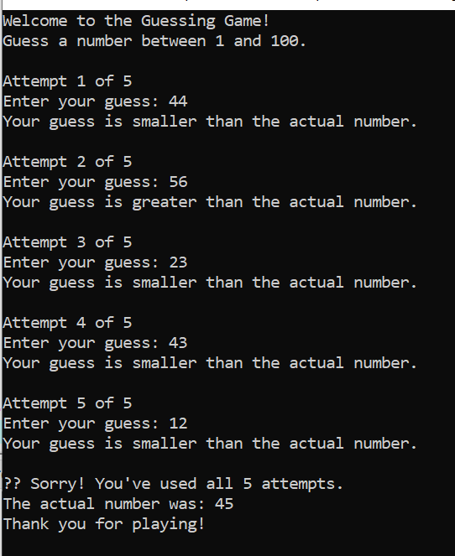
return 0;
}

5
Create a program for a simple shopping application, where a user will be shown a Menu from which he/she can select any product to purchase or enter zero (0) to exit the program as shown below: DEPARTMENT OF COMPUTER SCIENCE, SUKKUR IBA UNIVERSITY 18 PREPARED BY: ENGR. ZAINAB UMAIR As shown above, each product will also show its cost per item in the brackets. That Menu should be continuously shown to the user (so that the user can select multiple products (OR even the same product again) until and unless the user enters a zero (0), like
#include <iostream>
using namespace std;

int main() {
int choice;
int quantity;
double totalBill = 0.0;

cout << "==========================================" << endl;
cout << " Welcome to the Simple Shopping Program " << endl;
cout << "==========================================" << endl;

do {
cout << "\nMenu:" << endl;
cout << "1. Bread (Rs. 100)" << endl;
cout << "2. Milk (Rs. 80)" << endl;
cout << "3. Eggs (Rs. 150 per dozen)" << endl;
cout << "4. Rice (Rs. 200 per kg)" << endl;
cout << "0. Exit" << endl;
cout << "------------------------------------------" << endl;
cout << "Enter your choice (0 to Exit): ";
cin >> choice;

switch (choice) {
case 1:
cout << "Enter quantity of Bread: ";
cin >> quantity;
totalBill += quantity * 100;
break;
case 2:
cout << "Enter quantity of Milk: ";
cin >> quantity;
totalBill += quantity * 80;
break;
case 3:
cout << "Enter quantity of Eggs (dozen): ";
cin >> quantity;
totalBill += quantity * 150;
break;
case 4:
cout << "Enter quantity of Rice (kg): ";
cin >> quantity;
totalBill += quantity * 200;
break;
case 0:
cout << "\nExiting the program..." << endl;
break;
default:
cout << "Invalid choice! Please try again." << endl;
}

} while (choice != 0);

cout << "\n==========================================" << endl;
cout << "Your Total Bill: Rs. " << totalBill << endl;
cout << "Thank you for shopping with us!" << endl;
cout << "==========================================" << endl;

return 0;



